Department of Political science
Ambedkar College, Fatikroy
Observance of Constitution Day
The department of political science, Ambedkar College Fatikroy conducted 128th observance of Constitution Day on 26th November 2018 in the hall number 5 at 2 P.M. On that auspicious day Mr. Satyajit Das, HOD, Department of political science had given a valuable speech regarding the importance and significance of the day in front of the students and teachers. He also emphasized on the relevance of the day. 6 nos. of faculties and 120 nos. of students of the college also participated in the programme.
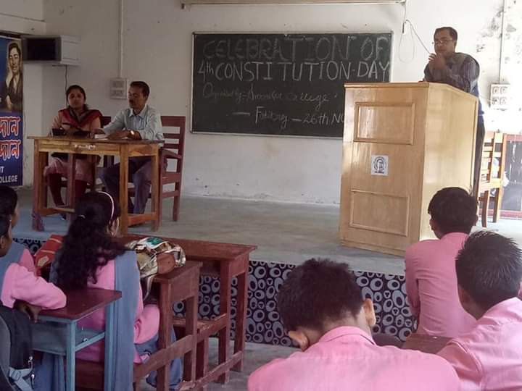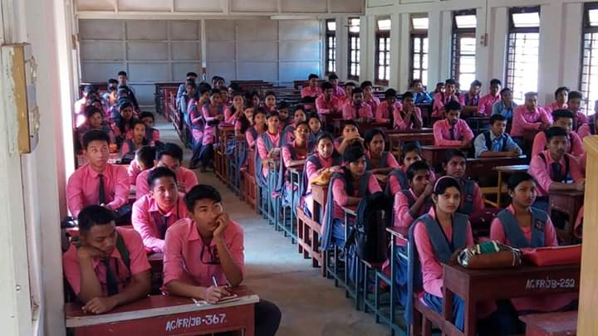

At the end of the day sweets were distributed among the students and teachers. The programme was ended with vote of thanks by Mr. Tapas Kr. Bhowmik.

